Types of ARP Entries
# Source: Chatgpt (GPT‑5 Mini) at [12/14/2025]
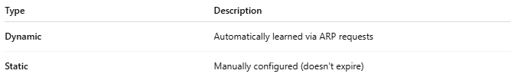
Type | Description
Dynamic | Automatically learned via ARP requests
Static | Manually configured (doesn't expire)

